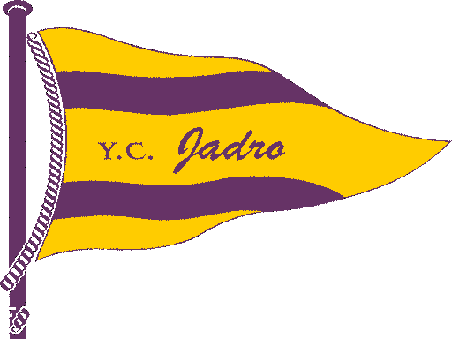

ENTRY FORM
Prvomajska regata-Guličev memorial
KOPER, 29.04.-01.05.2016

Sailing club: | Date: | Coach:
Class :
First and family name | Sail number | Date of birth | Gender M/F

Entry to be send by email not later than 27. April 2016 to
jk.jadro.koper@gmail.com

